# Name :- Yashita Prajapati ; Email Id :- [yashita980.be22@chitkara.edu.in](mailto:yashita980.be22@chitkara.edu.in)

***TOPIC - INTERACTIVE QUIZ***

# Name :- Pulkit Vashisht ; Email Id :- pulkit1012.be22@chitkara.edu.in

# Name :-Yatin Kalra ; Email Id :- [yatin983.be22@chitkara.edu.in](mailto:yatin983.be22@chitkara.edu.in)

# **ABSTRACT**

# The purpose of the project “interactive quiz” is to answer questions correctly which is a form of game or mind sport in which players attempt about a certain or variety of subjects. Quizzes can be used as a brief assessment in education and similar fields to measure growth in knowledge, abilities, or skills. They can also be televised for entertainment purposes, often in a game show format. In an educational context, a quiz is usually a form of a student assessment, but often has fewer questions of less difficulty and requires less time for completion than a test. During this pandemic, giving online quizzes was one of ways teaching was done. As we know, young learners can easily get bored and lack focus when they study for long periods of time. In order to cope with this limitation, we have to design fun quizzes for students. Unique features such as power-ups and live dashboard in Quizizz can boost their interest toward the quiz. Furthermore, there are several benefits of giving online quizzes for students.

**IMPLEMENTATION**

[Interactive quizzing](https://www.vevox.com/quizzing-with-vevox) can be used in many different ways, from setting the scene in a (virtual, hybrid or F2F) lecture or meeting with an icebreaker quiz to put everyone at ease, to running more intense quizzes to test knowledge throughout a session. Whatever the style of quiz you want to run, the quiz should naturally fit into your online presentation without deterring from your content. It should complement your presentation and add value rather than being a last-minute, badly run quiz. No one wants a quiz that flops!

**FLOW CHART OF INTERACTIVE QUIZ**

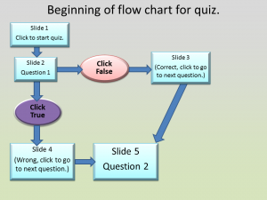

* **Tools/Technique:** Tkinter (GUI)
* **Mentor Name:**  Dr. Anand Muni Mishra